**DOCUMENTATION FOR STATES FOR RETIREMENT DASHBOARD**

The data was downloaded from this URL <https://www.bankrate.com/retirement/best-and-worst-states-for-retirement/> and imported into Power query for onward cleaning and transformation.

For the transformation on power query, I added an additional column, replaced values, changed data type, reordered, merged, and renamed columns where necessary for more efficient analysis.

Then I closed and applied onto Power BI to proceed with the analysis and visualization. The dashboard is below:

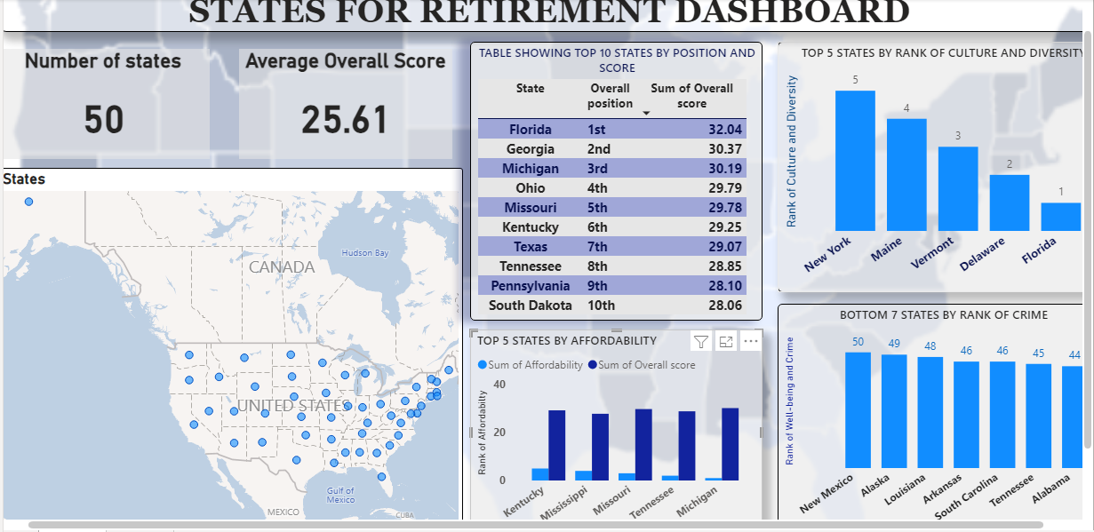

**Insights**

There were 50 states analyzed for North America under the basis of each state’s rank in crime, culture and diversity, well-being, affordability, and weather. With the average overall score as 25.61. From the data, Florida was seen to have the highest overall score which means it is the best state for retirement while the worst state according to the data is Alaska. New Hampshire was seen to be the safest state; Michigan the most affordable; Florida the most diverse and Arizona with the most conducive weather.